William Chirciu  
CSC 555 Project Phase 1

Cluster Status:

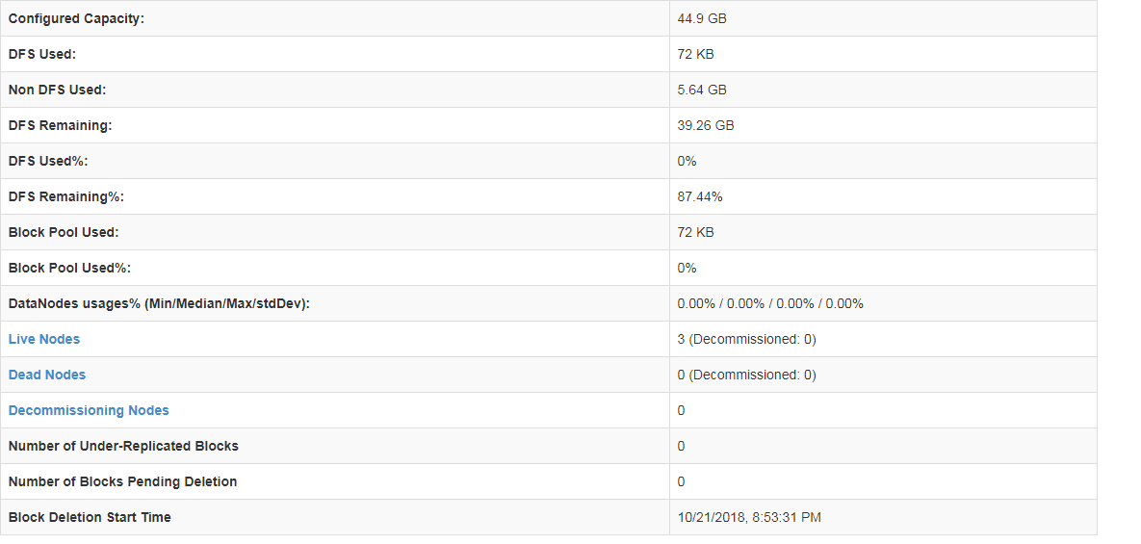

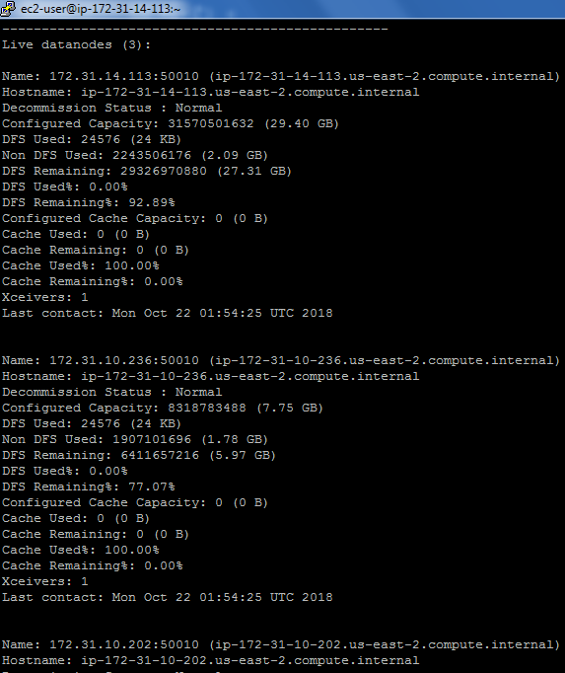

Running word count on bioproject.xml with our node cluster

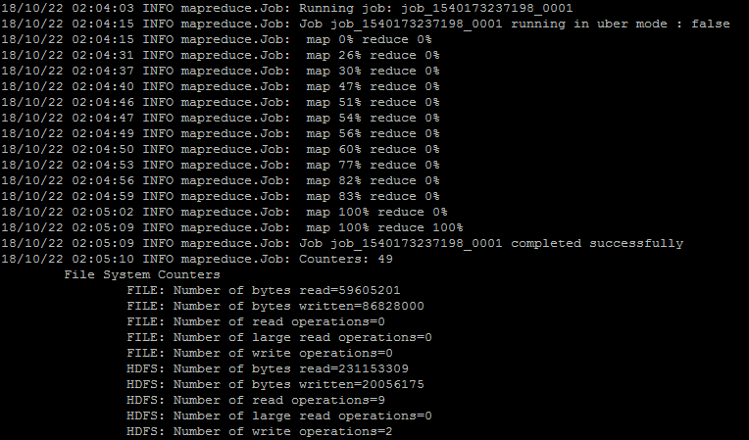

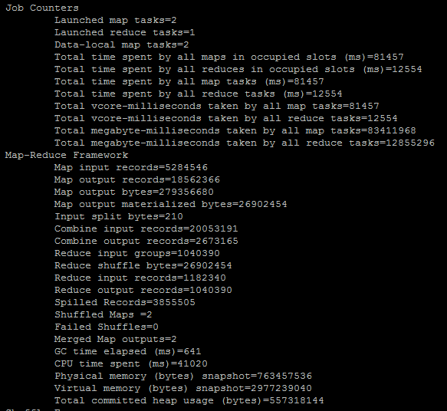

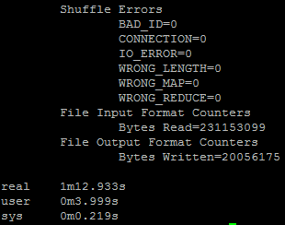

This job took 1 minute and 13 seconds with 2 map tasks and 1 reduce task.



**Part 2: Hive**

Query 1.2  
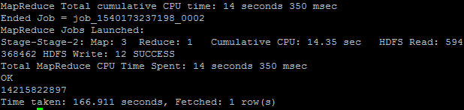

Query 1.3  
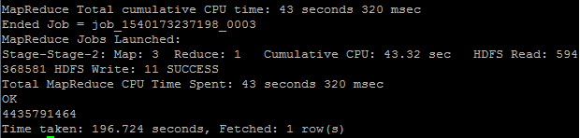

Query 2.2  
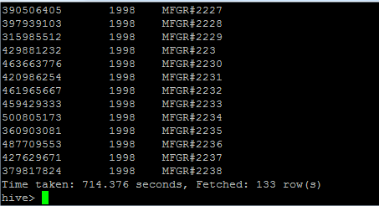

HIVE COMMAND FOR TRANSFORMING dwdate table

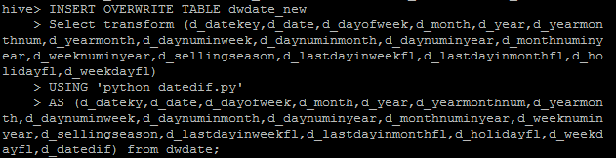

ASSOCIATED PYTHON CODE:

import sys

from datetime import date

for line in sys.stdin:

line = line.strip()

vals = line.split('\t')

#vals[8] = day number in month

#vals[10] = month num in year

#vals[4] = year

d1 = date(1994,11,1)

d2 = date(int(vals[4]),int(vals[10]),int(vals[8]))

diff = str((d2-d1).days)

vals.append(diff)

print '\t'.join(vals)

Some output of d_datediff column: used SELECT d_datediff from dwdate_new

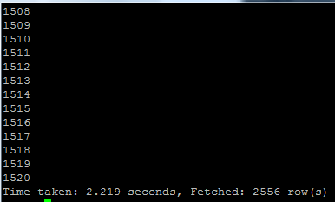

**Part 3: PIG**

**Query 0.1**

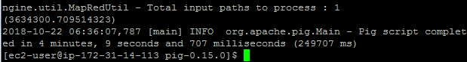

**Pig commands:**

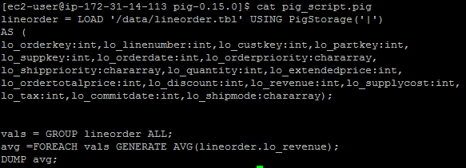

**Query 0.2**

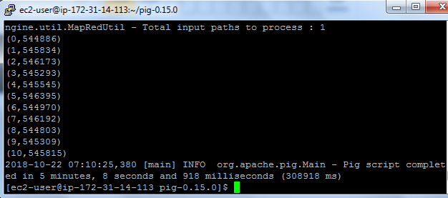

**Pig Commands:**

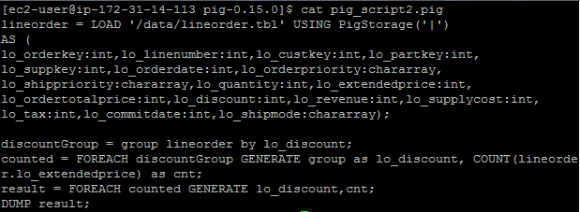

**Query 0.3**

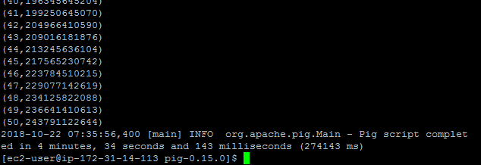

**Pig Commands:**

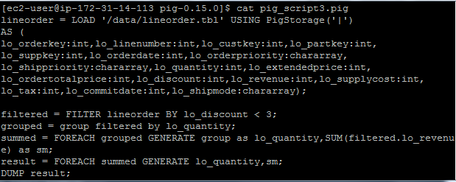

**Part 4: Hadoop Streaming**

**Mapper:**

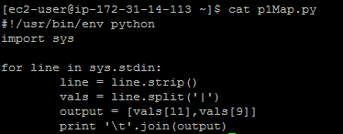

**Reducer:**

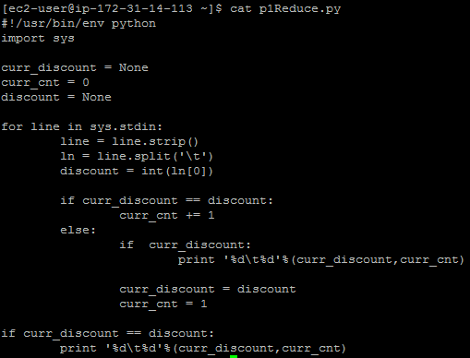

**Hadoop Streaming Command:**



**Output:**

